The Calculator Pad – Student Directions

Student Registration:
Before a student can use The Calculator Pad (a.k.a., CalcPad) with our Task Tracker, they must first register for a teacher's class using a Class Sign Up Code. The procedure is as follows.
1. Go to the Account page. There is a link to Account near the bottom of the left-side navigation panel on every page and just below The Physics Classroom title at the top of every page.
2. On the right side of the Account page, there is a link titled Register as Student.
3. Students should create an account by filling out the form and tapping on Register. Students need to use a teacher's Class Sign Up Code (i.e., Course Code) when they fill out the form. Students must also enter a password twice and an accurate security code (in the grey box).
4. Once an account is created and linked to a teacher's course, students will see their main account page. By tapping on the Tasks and Courses link, they will navigate to the teacher's Course page where assignment information is listed.

Selecting and Starting Assignments
Once a student is added to a class, they can begin using CalcPad (and any other purchased Task Tracker feature their teacher is subscribed to) and have their progress saved. The procedure is very easy.
1. Tap on the Account link found near the bottom of the left-side navigation panel on every page and just below The Physics Classroom title at the top of every page. If not logged in, then log in using the email address and password used at registration.
2. Tap on the Tasks and Courses link to navigate to the Course page where assigned tasks are shown. Students will see all assignments organized by topic. If there is more than one topic, then a student can tap on the topic to view assignments for that topic.
3. Due dates and scoring information are available for each assigned task. A color coding and number system is used to indicate the urgency of an assigned task relative to the due date. Green indicates that the assigned task has been completed. Blue indicates that an incomplete task is approaching the due date (7 days away). Yellow indicates that the due date is very soon (48 hours away). And Grey indicates its more than a week away. Red indicates that the task is not complete and past the due date but can still be completed for late credit. Black indicates that the task is overdue and no longer credit-able. The numbers inside of each oval indicate the number of tasks with that urgency level.
4. To start an assigned problem set (referred to as a "task"), tap on the Start This Task link. This opens the assigned Problem Set at The Calculator Pad. Make sure that you do NOT see a yellow notice stating "This is the guest version of the assignment … ". If you do, then there's something wrong and your progress will not be tracked. The graphic below explains the top part of the page.

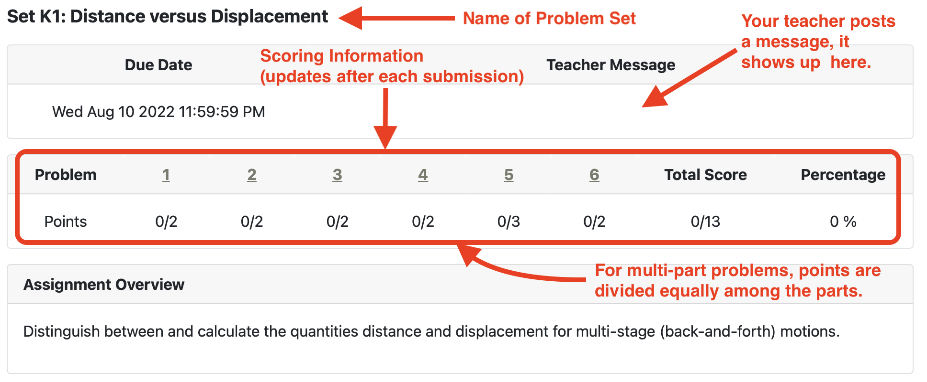
5. Completion of a problem set involves providing correct answers to problems. Each answer field has its own Submit button. Enter an answer and tap Submit. Feedback is immediate and scores are updated. CalcPad stores everything; what you see on the screen is saved in the database for your teacher to view. See graphic below for more information about a CalcPad problem.

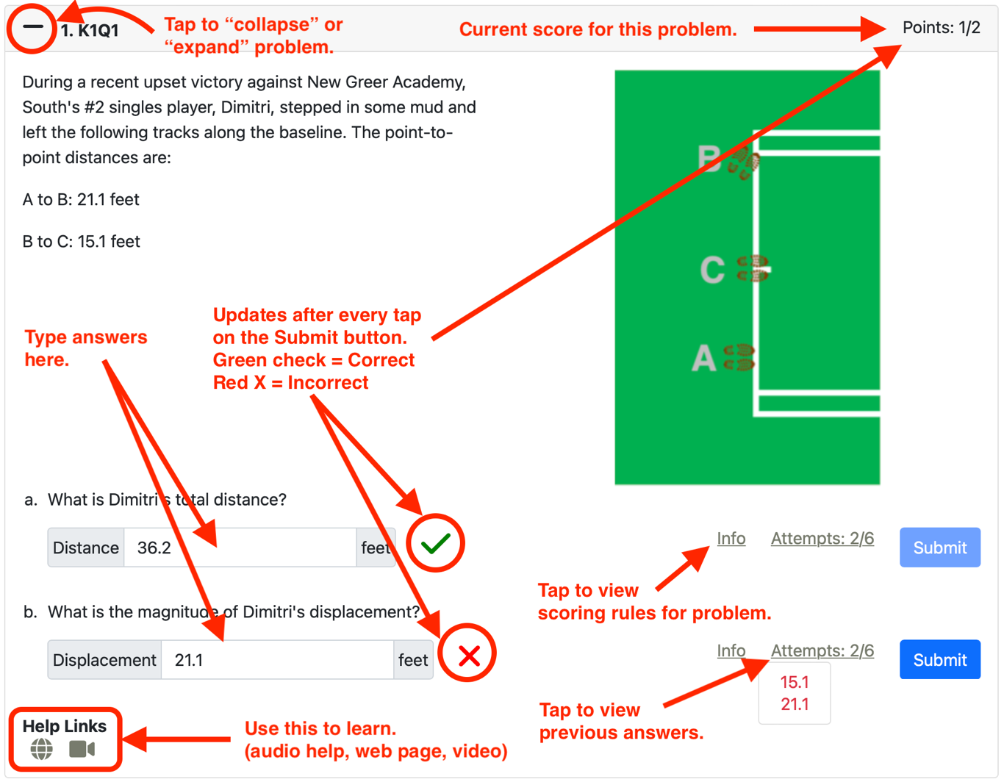

Note that CalcPad keeps a record of your submission history. You can never enter the same value twice (like, who would want to). And once you have the right answer, the Submit button is diabled. Most every problem has some Help Links. An audio help link (denoted by a headphones icon) may be the most useful and detailed. The web page (denoted by a globe icon) will link to a Tutorial page about the topic. The video (denoted by a video camera icon) will link to a YouTube Tutorial on the topic. Get help before you get frustrated. The goal is to learn; the CalcPad tool is designed to help.

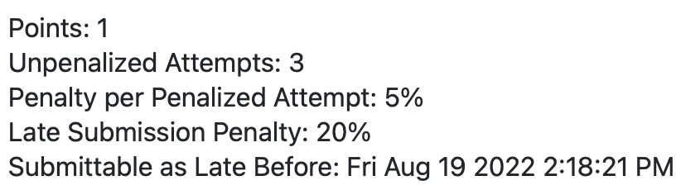
On occasion, you will want know how a problem is scored. A tap on Info will reveal that information. Sometimes its scored such that an excessive number of attempts will result in a reduced score. You may also want to know the point reduction for submitting late answers. And finally, a CalcPad problem set is often set to shut down after a certain date. Check the Submittable as Late Before date. After this date, the Submit button will no longer work.

